# User Manual: Electro-Assis

Written by: Derek Gerry, 10-13-24. (812-435-9081)

The Electro-Assis can be runs from a Python GIU called Tkinter.

This program will calculate the missing electrical element, current, voltage or resistance, if two of the other values are known.

The pictures need to be located in the same directory Python is run from. In my case that was: C:/Users/User Name, since Python is run in a sub-directory from this location. (A specific directory was not chosen since everyone’s computer is different.) The Python Program itself will run fine from any location.

After running the program, this window will appear.

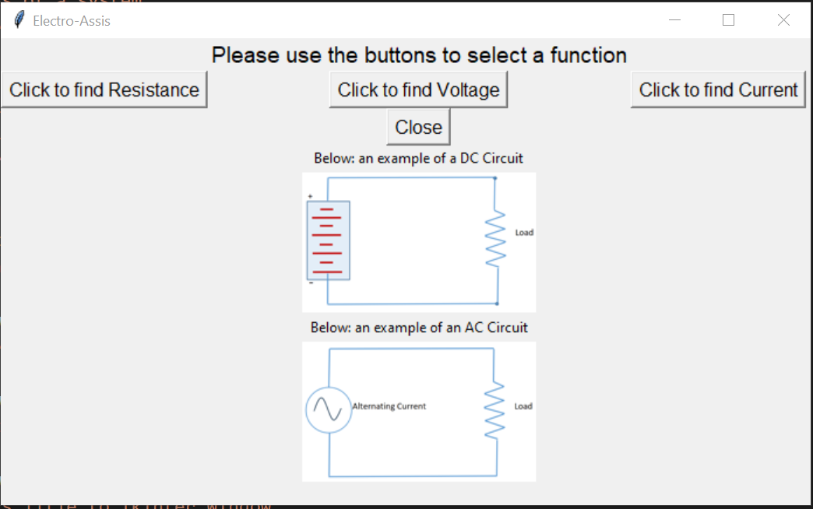

From this window, all of functions of the calculator will be called and run in separate windows.

The ‘Close’ button from this window will close all open Tkinter windows.

Pressing a button will open it corresponding function window. Not just one, but all three can be opened at one time if you chose.

Below is what the Find Resistance window looks like.

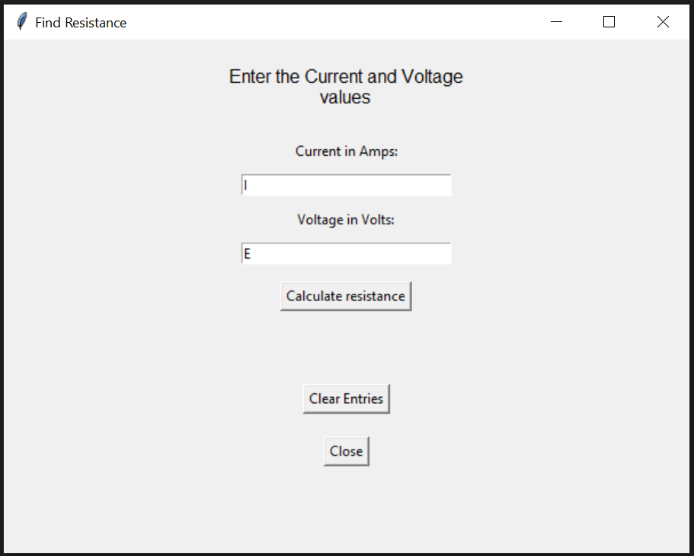

Notice that the two data entry fields are not blank. Each has its electric equivalent symbol.

I = Amperage, current. E = Voltage.

These initial values can be cleared by pressing the, ‘Clear Entries’ button or clicking in the Data entry box and pressing the backspace key on your keyboard.

After entering the values, you wish to use, press the Calculate xxx button to see the results. The next picture shows what this looks like.

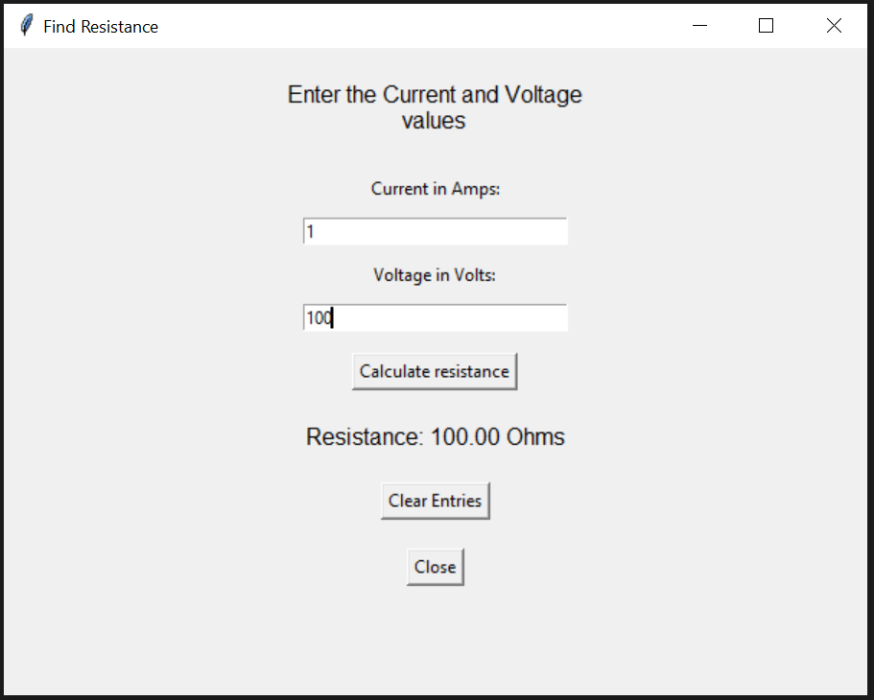

Press the, ‘Clear Entries’, button to use new values, or the ‘Close’ button to close this screen.

If you accidentally enter a non-accepted value, the error below will display.

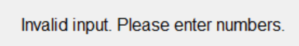

All three of the windows that open from the main page after clicking a corresponding button will work the same way.